

3-7 june, 2026
TIMIRYAzEV Exhibition Center
Moscow, Verkhnyaya Alley, 8,

SPACE APPLICATION FORM
COMPANY NAME:
BRAND NAME:
POST CODE: |  | COUNTRY: |  |  |  |  | CITY:
PO BOX CODE & STREET:
TEL.: |  | FAX.: |  |  |  |  | CELL:
E-MAIL:
BANK NAME: |  |  |  |  | BRANCH NAME:
IBAN: |  |  |  |  | SWIFT:
ACCOUNT NUMBER:
RESPONSIBLE PERSON:
JOB TITLE:
PRODUCTS TO BE EXHIBITED:
MARK COMPANY TYPE: |  | PRODUCER |  |  |  | WHOLESALER

399EUR*
(per 1 sq.m.)
399EUR*  (per 1 sq.m.) | EQUIPPED SPACE: |  | SQM
399EUR*  (per 1 sq.m.) | MINIMUM size is 9 sq.m.

320EUR*
(per 1 sq.m.)
320EUR*  (per 1 sq.m.) | UNEQUIPPED SPACE: |  | SQM
320EUR*  (per 1 sq.m.) | MINIMUM size is 18 sq.m.

OBLIGATORY REGISTRATION FEE 567 EUR includes: registration of 5employees, company description in the Russian/English online application JUNWEX, 5 complimentary tickets.
SURCHARGE FOR LOCATION:
BOOTH  TYPES: | A (1 SIDE OPEN) | С (3 SIDE OPEN) — 15% | C |  | B |  | D
BOOTH  TYPES: | В (2 SIDE OPEN) — 10% | D (4 SIDE OPEN) — 20% | C | A |  |  | D

We hereby confirm our participation in the JUNWEX New Russian Style 2026
Authorized signature:_____________________ Stamp : ____________________Date:«_____» ___________202_

PLEASE RETURN THIS FILLED FORM TO MEDIA-HOLDING JUNWEX
E-mail: budnaya@mail.ru
Tel/Fax:+7 812 320 80 99 www.junwex.com
DEADLINE FOR APPLICATION IS 1 April 2026!!!

*-prices in another currency shall be agreed with the Organizer.

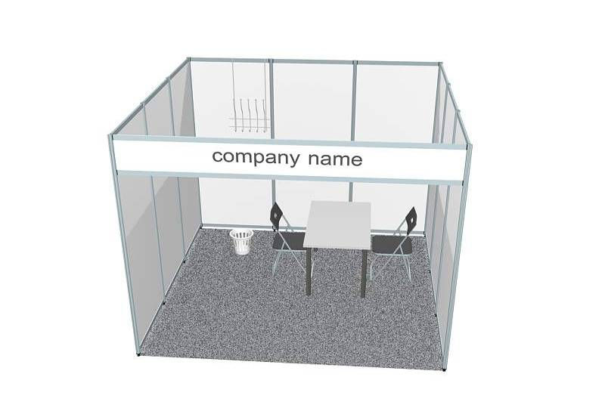

SHELL SCHEME (built through Organisers)

Standard shell scheme booth includes:

- exhibition stand of ordered size made of white wall panels 2500х1000х4 mm with aluminium profile
- carpet (grey)
- fascia panel
- fascia panel name – 10 characters total (Cyrillic or Latin) free of charge (extra characters are to be paid. Don’t forget to order according to number of open sides)
- 1 table (670х670 cm)
- 2 chairs (black)
- 1 waste basket
- 1 coat rack fixed to wall
- 1 spot light (reflector lamp 100W)

Please note: Electrical consumption and plug sockets are not included in the shell scheme and need to be ordered separately

